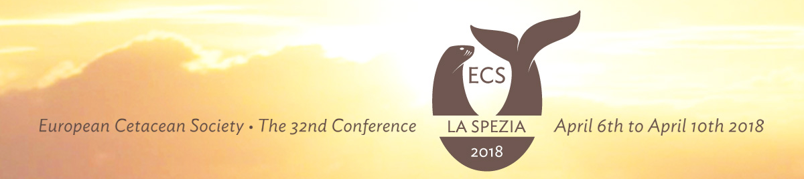
WORKSHOP PROPOSAL FORM
for the 6th and 7th April 2018
Details of principle contact person
Name of Organiser:
Institution:
Contact e-mail:

Workshop Title:
Aim:
Anticipated outcome:
Summary of Proposal (max 300 words and indicate expected output):

Duration is: | Half day |  |  | Full day |  |  | Other

Preferred Day: | Friday 6th Apr |  |  | Saturday 7th Apr

Participation is: | Open |  |  | Closed

Number of participants: |  |  | and type (student, experts):

Has this proposal secured external funding? |  | No |  |  | Yes |  |  |  | If Yes then from whom and how much

Notes:
Costs and charges are worked out after proposal is accepted for the conference programme.
Refer to conference website for more details and deadlines at:
http://www.europeancetaceansociety.eu/conference/32nd-annual-conference-italy

Return this proposal at latest by 19 Jan 2018 to
abstract.ecs.la.spezia@gmail.com

